Bryan Guner

5/1/15

TST-161

Spring 2015

Fire Extinguishing Robot Documentation Report

(Design)

Our Fire Extinguishing robot was designed based on the “mouse trap car” framework. This configuration uses the stored energy in a mousetrap, to propel our robot forward a fixed distance before triggering a fan(Calibre) to extinguish a candle flame. This robot, in essence, is simply a platform on wheels that has a mousetrap (Victor) mounted on top with an extended lever arm (to reduce mechanical advantage). The lever arm is attached to a string (Cirrus Twine), which is curled around one of the axles made out of a wooden dowel (Home Depot), such that when the mousetrap is released the lever arm causes the axle to spin. The other axle was connected by a specific length of string to the fan’s switch, so that when the robot had traveled 10 feet, the switch would be pulled, activating the fan and stopping the car simultaneously. Pictures of the construction can be seen below in figures 1-4.

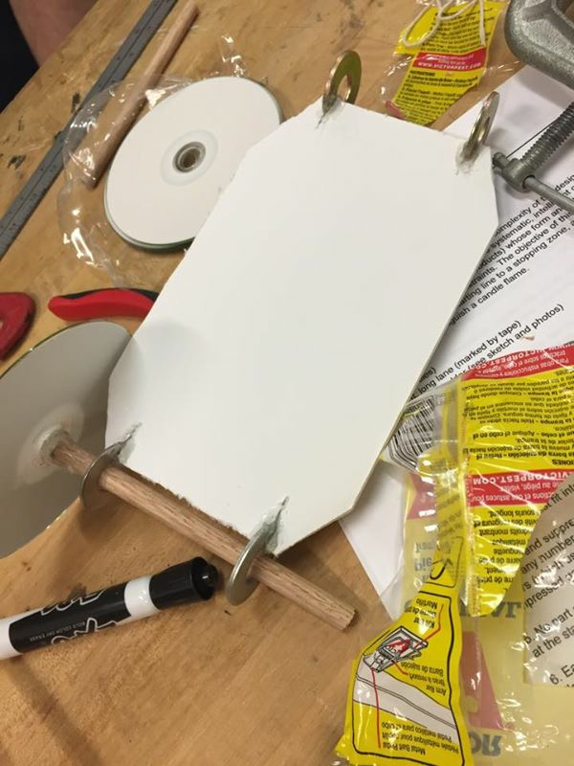

Figure 1: (The baseboard with one incomplete axle about to be mounted)

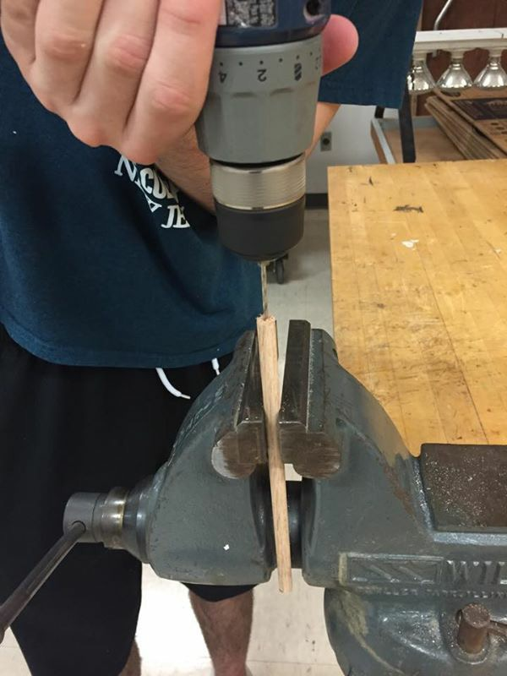

Figure 2: (Lever arm being drilled in preparation for attachment to mousetrap)

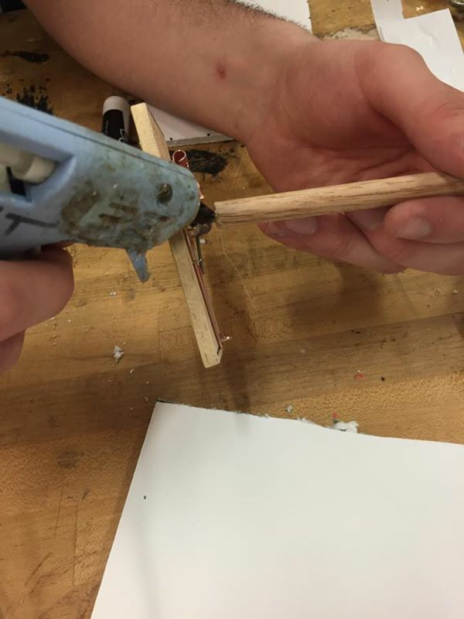

Figure3: (Attaching lever arm to mousetrap)

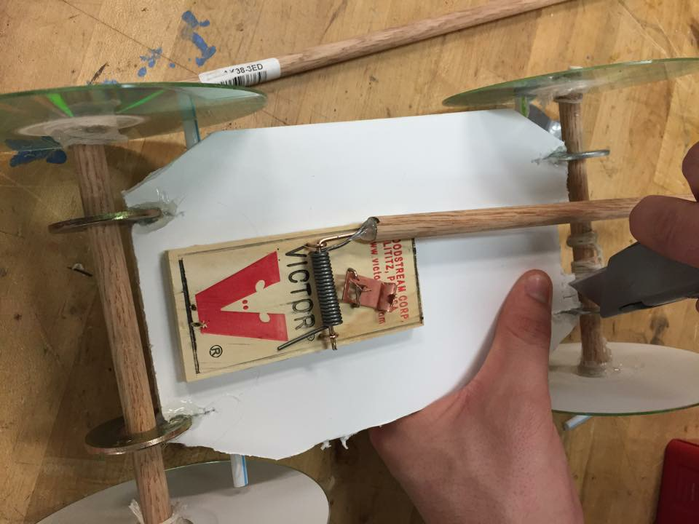

Figure 4: (Mousetrap mounted on platform and connecting string wrapped around axle)

References:

(1) Calibre, bullet series mini fan

(2) Home Depot, wooden dowel

(3) Memorex, 80min CDs

(4) Victor, mousetraps

(Inspiration and Instruction)

While the unique integration of each component into the final product formed an original design, the underlying mechanisms were established well before we decided to put them together. Our main source of guidance was an anonymous Internet article called “mousetrap cars” (Ideas-Inspire, mousetrap cars), written by a mousetrap car enthusiast who outlined not only how to build a mousetrap car, but how to custom tailor it to your specifications. All of these tidbits of advice were supported by scientific explanations of the physical principles at work. From this source, we discovered that it would be ideal to extend the mousetrap’s lever arm such that mechanical advantage would be reduced, and distance traveled therefore increased, at the cost of the force with which the car traveled. The enthusiast also suggested that we accompany very thin wheels with an extended lever arm, because force would be reduced, and as a result, for motion to take place, friction must be reduced to the greatest extent possible. This suggestion ultimately led to our choice of CDs as wheels. A sketch of our design can be seen below in figure 5. As for procedural instructions for the construction of a mousetrap car we used the wiki-how guide online (Wiki How, How to build a mousetrap car). While we toyed with many configurations, and even concepts for how to approach the task at hand, we ultimately settled on a mousetrap car for it’s simplicity and cost effectiveness.

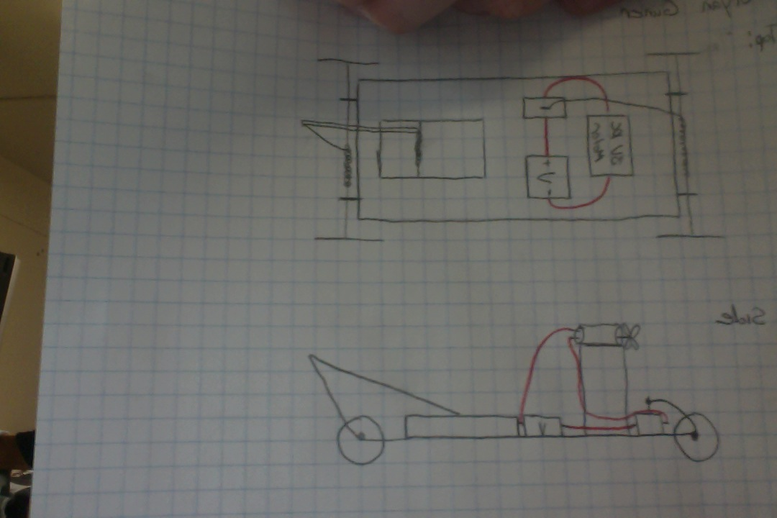

Figure 5;( Sketch of our original mousetrap concept from top and side views, red wires are electrical)

References

1. Ideas-Inspire, Mousetrap Cars , retrieved April 15, 2015, from <http://ideas-inspire.com/mousetrap-cars/>.
2. Wiki How, How to build a mousetrap car , retrieved April 15,2015, from <http://www.wikihow.com/Build-a-Mousetrap-Car>

(Alternative Designs)

While we ultimately settled on a mousetrap car for our fire-extinguishing platform, because of its ease of design and construction, we originally considered many different approaches. Below are outlined the three alternatives we gave the most consideration.

1. One concept we considered, was a speaker system that used controlled sound from a subwoofer rather than air from a fan to extinguish a candle flame. This concept may sound absurd, however, there are many videos of the phenomena at work on the Internet. Unfortunately, this approach was ruled out due to both the complication and expense of utilizing sound technology to put out a fire, not to mention a group-wide lack of the know-how necessary to put this principle to work.
2. Another configuration we considered more seriously was an automated robot, controlled by a preprogrammed micro controller. The idea was to have a chassis on motor driven wheels with a fan and obstruction sensor mounted to the top. We could then program the micro controller to move forward in a straight line until the obstruction sensor detected the candle. At this point the microcontroller would turn off the motors and divert power to the fan in order to extinguish the candle. This approach seemed viable especially because we already possessed the necessary microcontroller, however, our hops were ultimately in vain, as no group members possessed the skill necessary to program the controller.
3. Our most viable alternative worked almost identically to the mousetrap car in that it called for the process to be controlled by mechanical energy stored in a rotating cog. This design was never realized because we could not source or create the cog we had envisioned to store the energy.

(Design Changes during Testing)

Our final design was nearly identical to the original one. The only major differences were, replacing the battery-motor-switch component with a mass-produced mini fan to save time, and attaching the string responsible for breaking/fan activation to an axis rather than to the extended lever arm. Another alteration made during construction, was abandoning the elevated loop responsible for guiding the string attached to the breaking axis(as seen in figure 6) to the fan switch for a more highly sensitive switch attached directly to the breaking axis (figure 7).

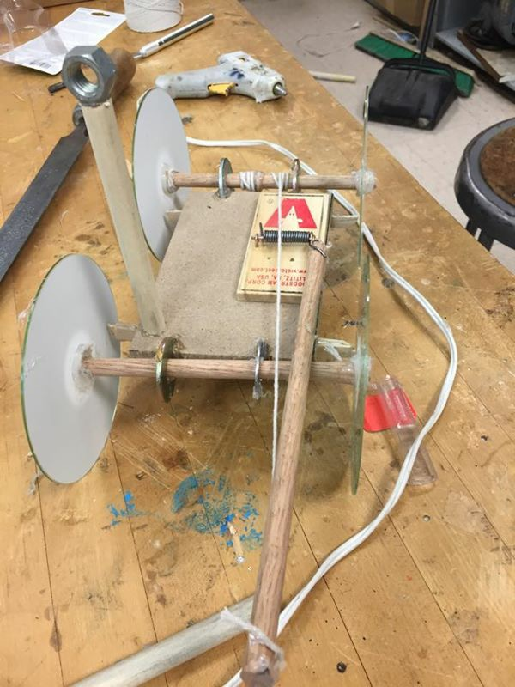

Figure 6: (Mousetrap car with guiding loop before the fan was attached)

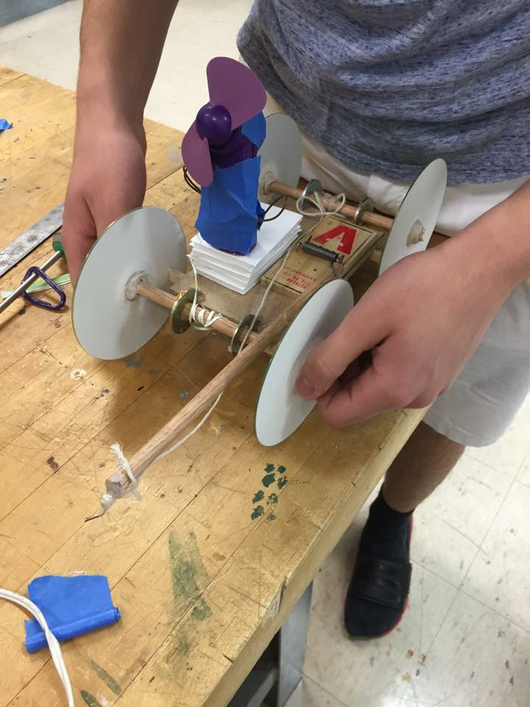

Figure 7: ( Finished product with altered fan switch and elevated fan platform)